BU [DFCT0012581](https://bu.service-now.com/rm_defect.do?sys_id=452181764f97a640164ad49f0310c751&sysparm_record_target=rm_defect&sysparm_record_row=20&sysparm_record_rows=23&sysparm_record_list=active%3Dtrue%5Eassignment_group%3Djavascript%3AgetMyGroups%28%29%5EORassignment_group%3D61aabdca0a0a3caa00956814d4efc75a%5Eu_product%21%3D7d7dd73b21805dc0495428ab391b3e5b%5EORDERBYu_defect_state)

Kuali Co Demo site 1/10/2017 <https://res-demo2.kuali.co> Subaward 88 Award 000316-00001 to 000316-00003.

Summary: When a Subaward is re-versioned without changes and submitted, the fields listed below which are populated from the Financial tab no longer appear populated on the FDP Modification printout. This is true for all modification types: continuation, increment, no cost extension and other.

* Amount Funded This Action
* Amendment No.
* Effective Date of Amendment
* The Actions section

Expected Result: The amendment transaction entered on the Financial tab in the History of Changes panel should appear on the FDP Agreement when printed. The most recent amendment data should not be tied to the version in which it was originally entered.

Steps:

1. Enter a new Subaward. On the Financial tab in the History of Changes panel, add a transaction with a modification id of 000 then populate all the fields in the History of Changes panel. Submit the Subaward.
2. Edit the Subaward. On the Financial tab in the History of Changes panel, add a second transaction. Use a modification id of 001 and select the first ‘modification type’ in the dropdown e.g. continuation. Submit the Subaward.
3. From the Subaward Actions tab in the Print panel, select FDP Modification and click Print. Save first printout (see page #3).
4. Edit the Subaward creating version #2. Make no changes and submit. From the Subaward Actions tab in the Print panel, select FDP Modification and click Print. Save second printout.
5. Compare first printout to second printout. Notice the following fields are now null:
   * Amount Funded This Action
   * Amendment No.
   * Effective Date of Amendment
   * The Actions section

Screenshots of Subaward 88 from Kuali Demo are provided below:

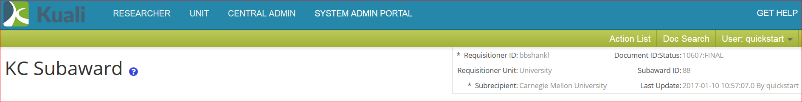

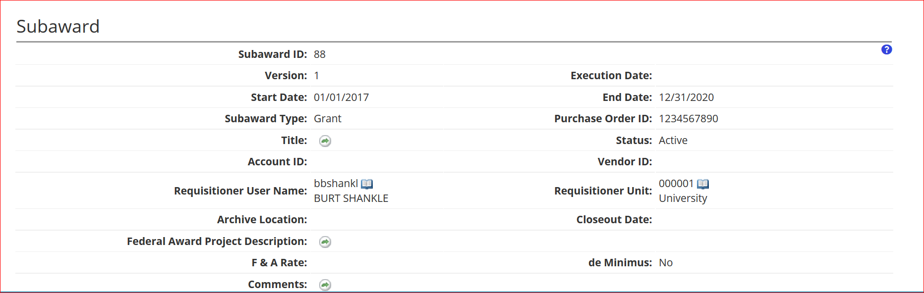

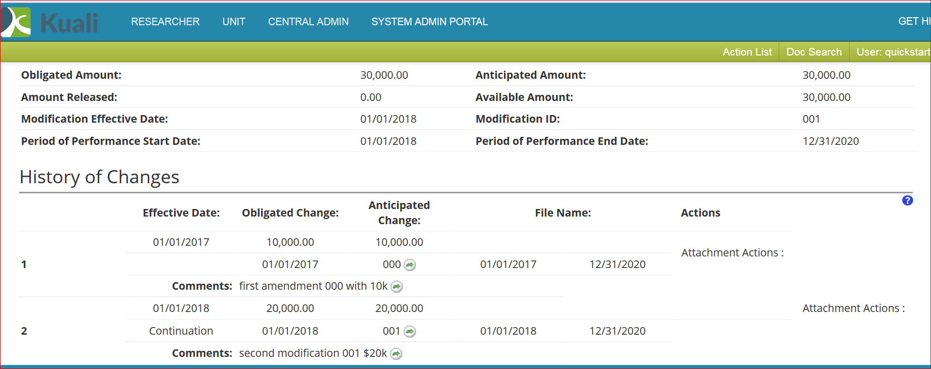

Screenshot from Kuali Demo FDP Modification printout #1 for Continuation Subaward version #1 is provided below.

Ancillary Note: In Kuali Demo Subrecipient Principal Investigator (PI) is not populated on the FDP Modification although Site Investigator and Subrecipient are both populated on Subaward 88. This is being mentioned for the sake of awareness but is not the primary focus of this test plan. The loss of data when a Subaward is versioned without making any changes to the Subaward is the primary focus of this test plan.

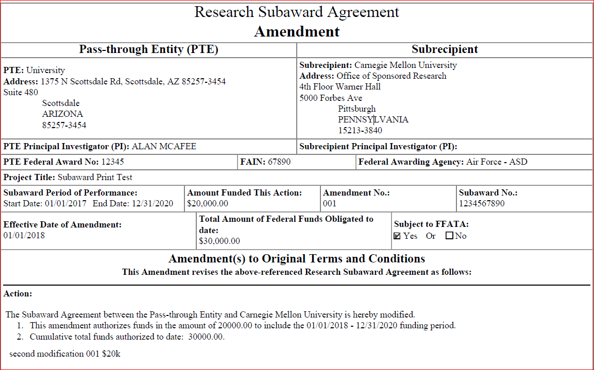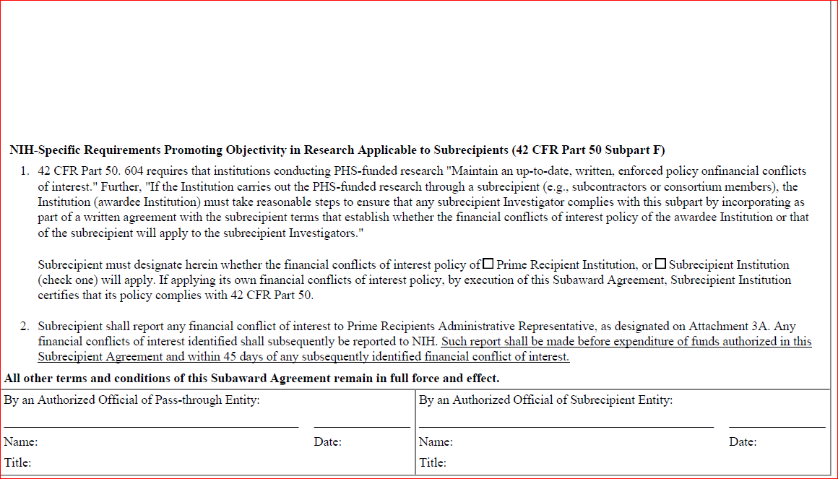

Screenshot from Kuali Demo FDP Modification printout #2 for Continuation after Subaward is edited and submitted without changes creating Subaward version #2 is provided below.

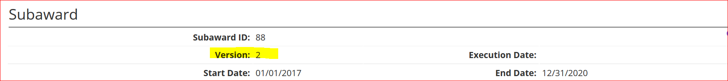

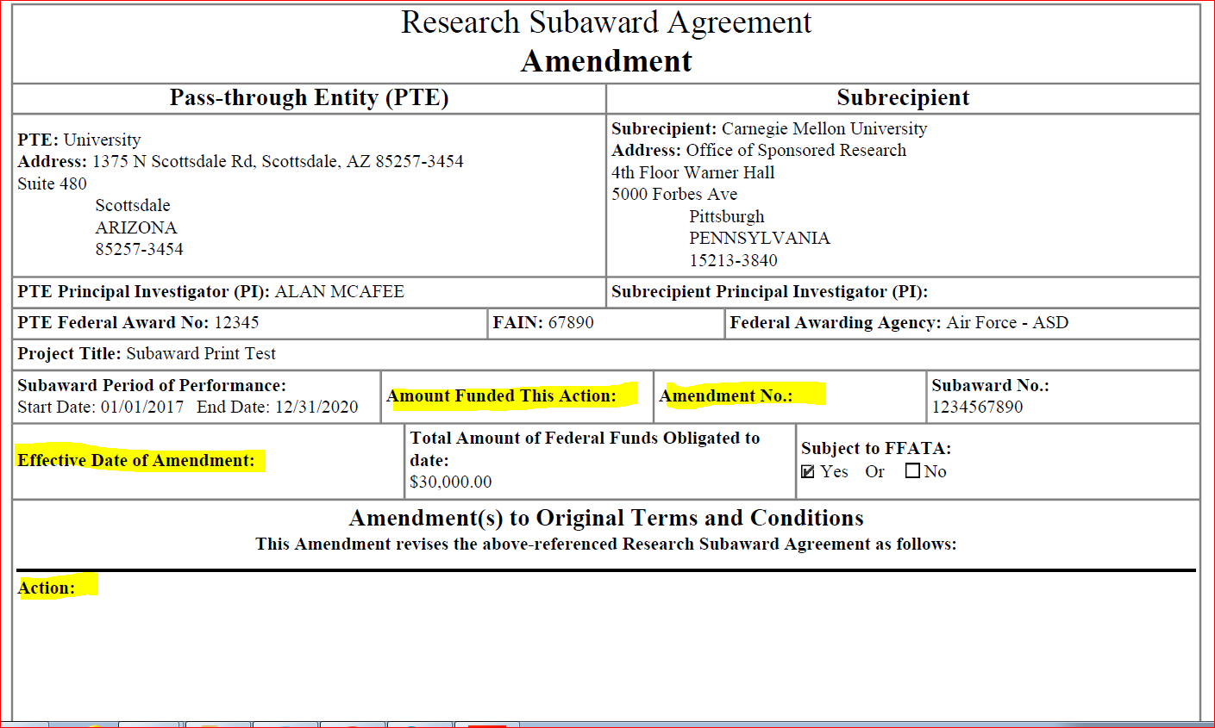

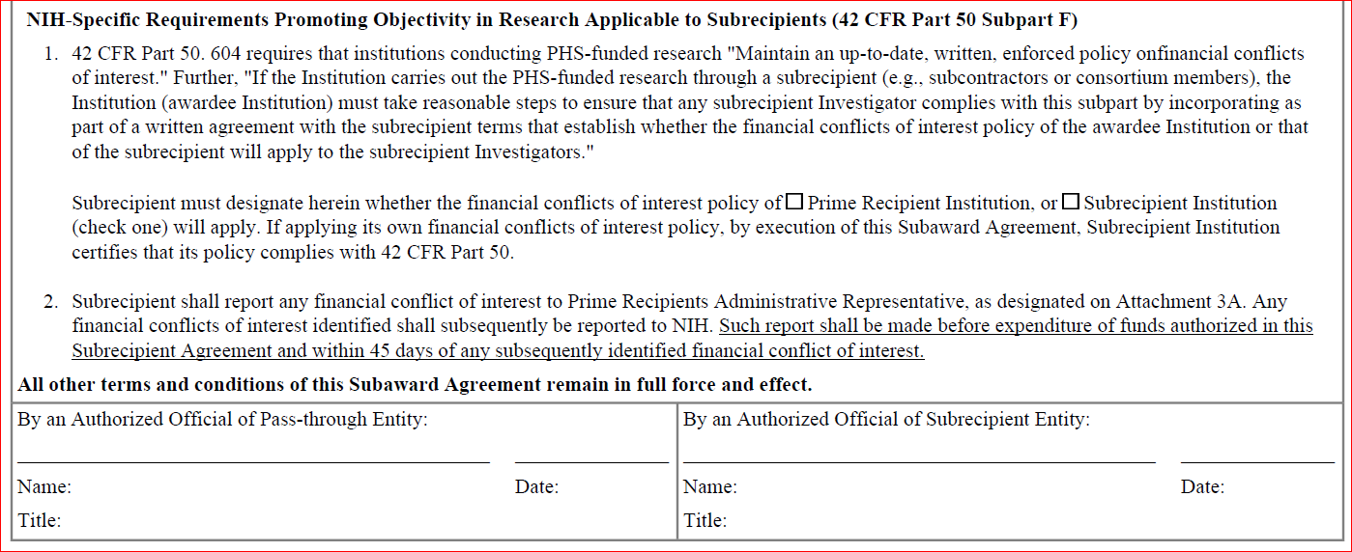

Repeat the steps provided above adding another transaction in the History of Changes panel with a Modification Type of ‘Increment’. Screenshot from Kuali Demo FDP Modification printout #1 for Increment is provided below.

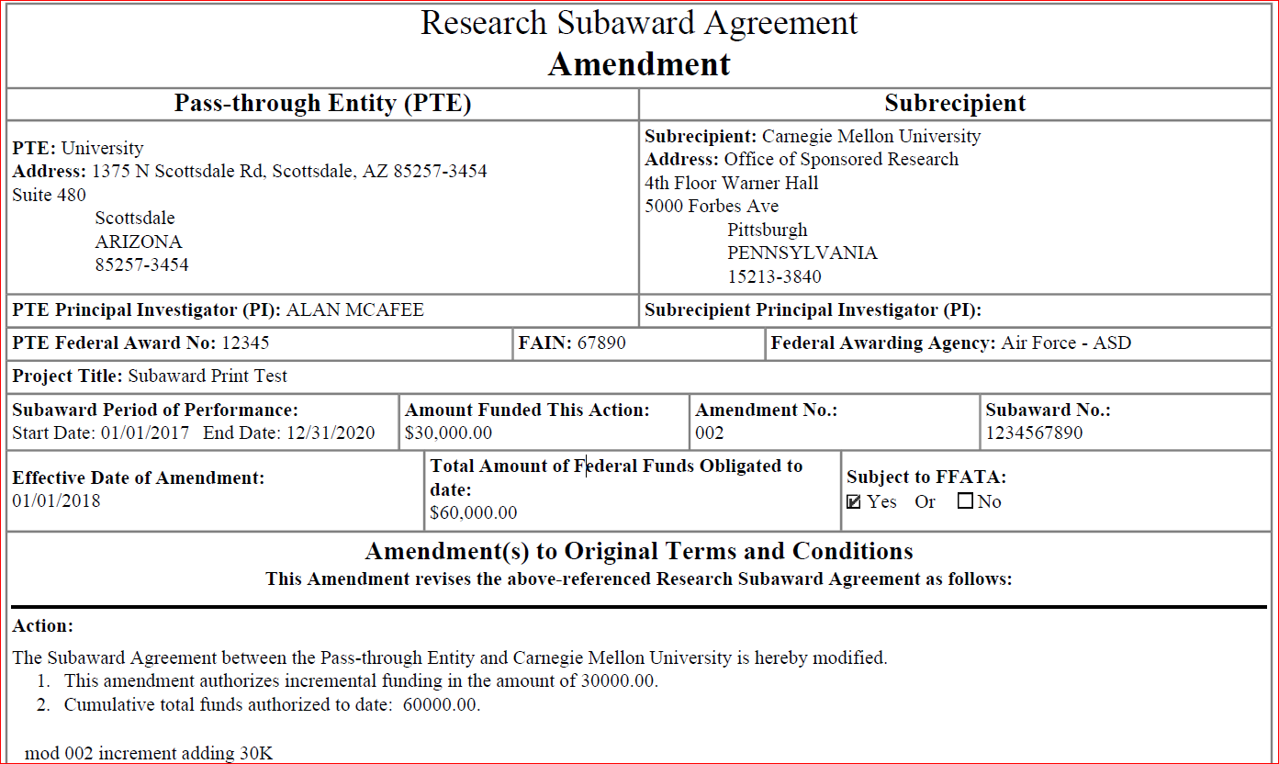

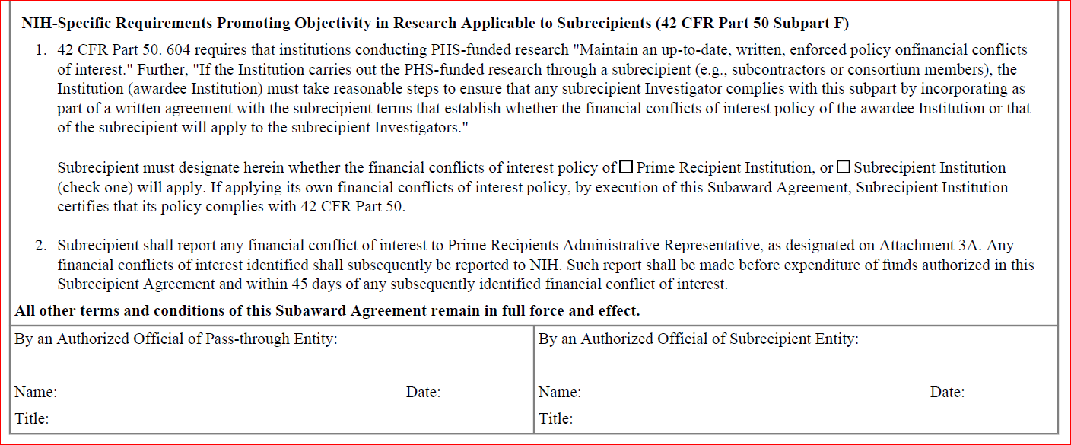

Screenshot from Kuali Demo FDP Modification printout #2 for Increment after Subaward is edited and submitted without changes creating version #4 is provided below.

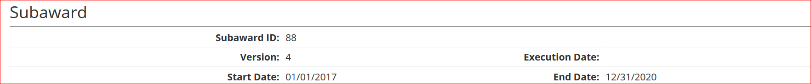

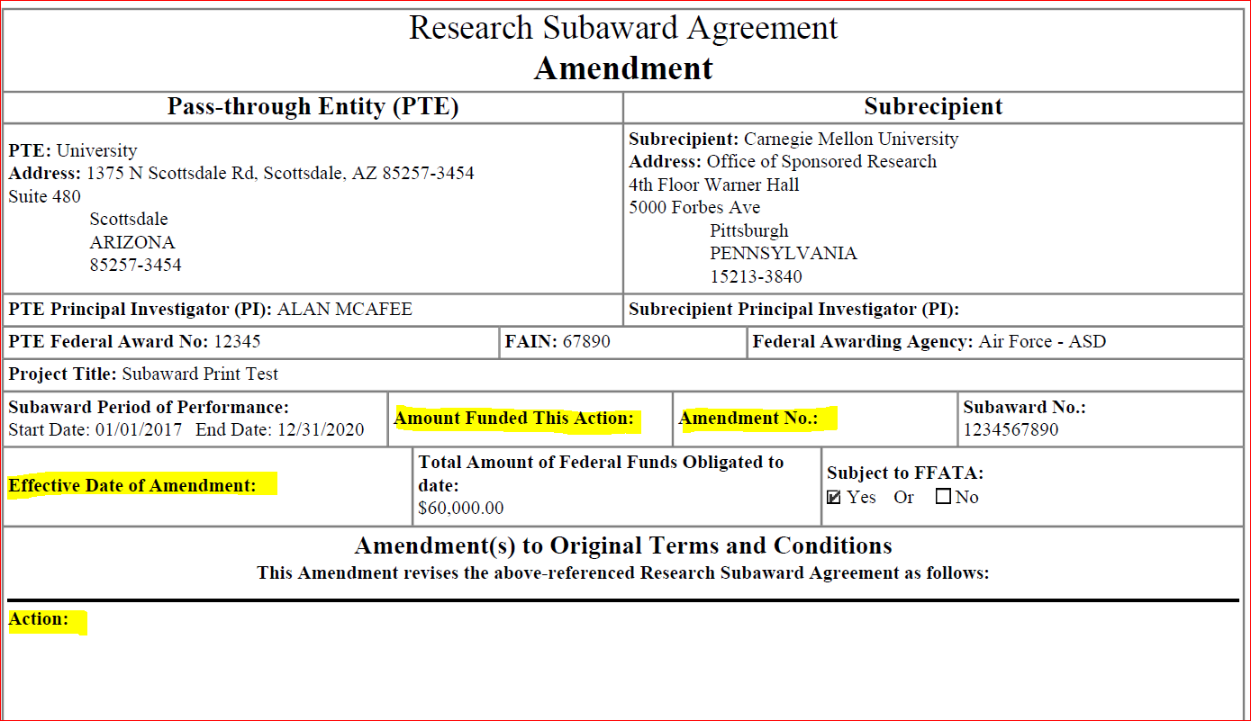

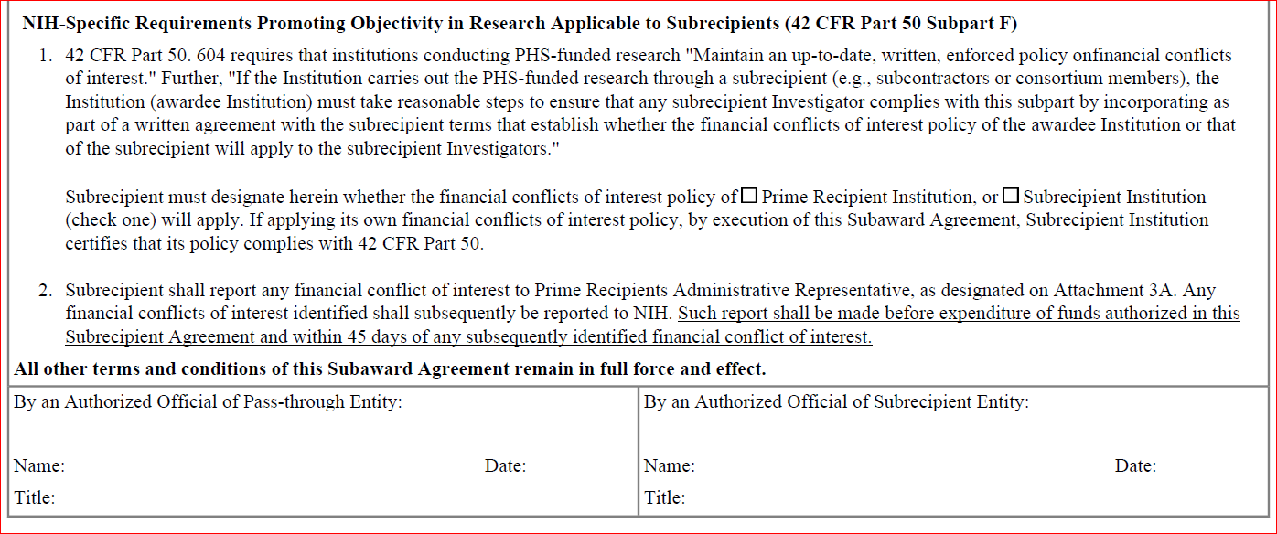

Repeat the steps provided above adding another transaction in the History of Changes panel with a Modification Type of ‘No Cost Extension’. Screenshot from Kuali Demo FDP Modification printout #1 for Increment is provided below.

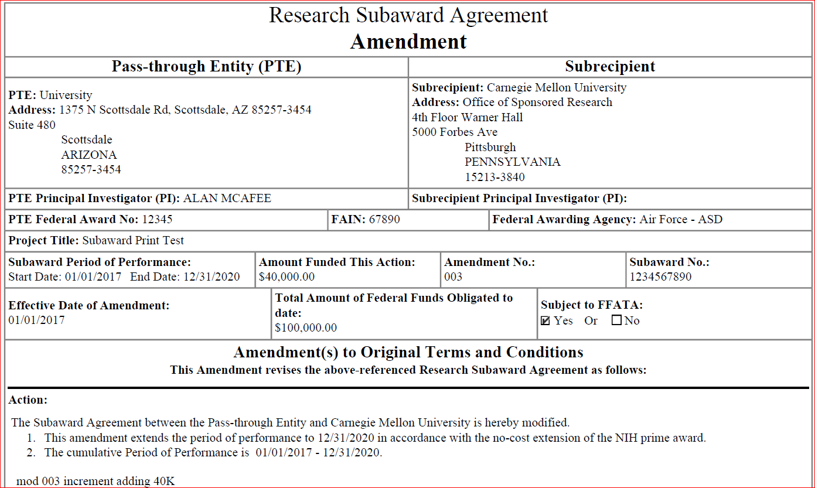

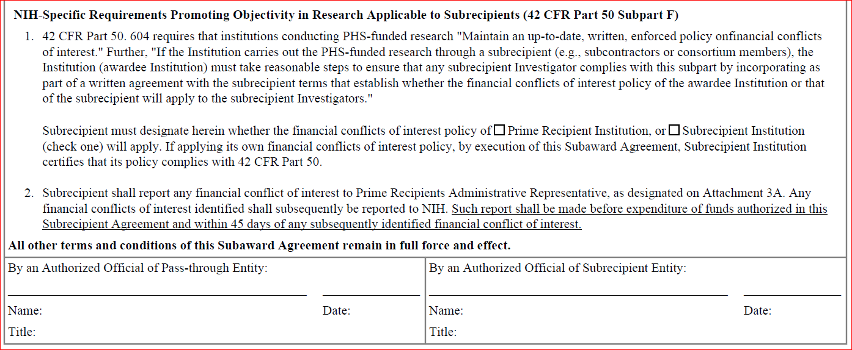

Screenshot from Kuali Demo FDP Modification printout #2 for ‘No Cost Extension’ after Subaward is edited and submitted without changes creating version #6 is provided below.

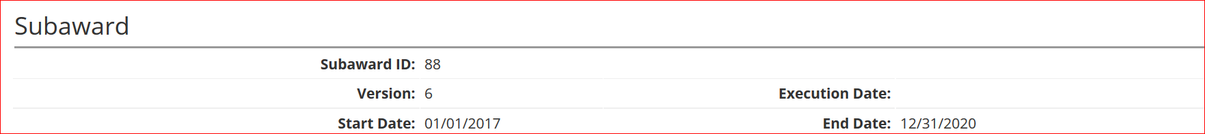

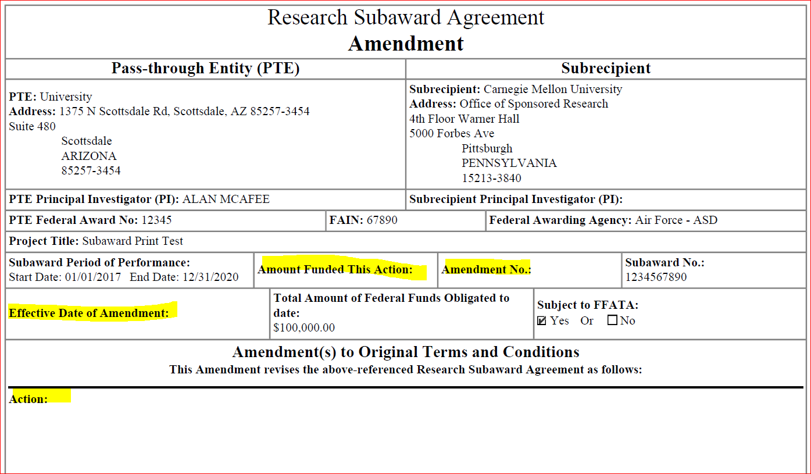



Repeat the steps provided above adding another transaction in the History of Changes panel with a Modification Type of ‘Other’. Screenshot from Kuali Demo FDP Modification printout #1 for Increment is provided below.

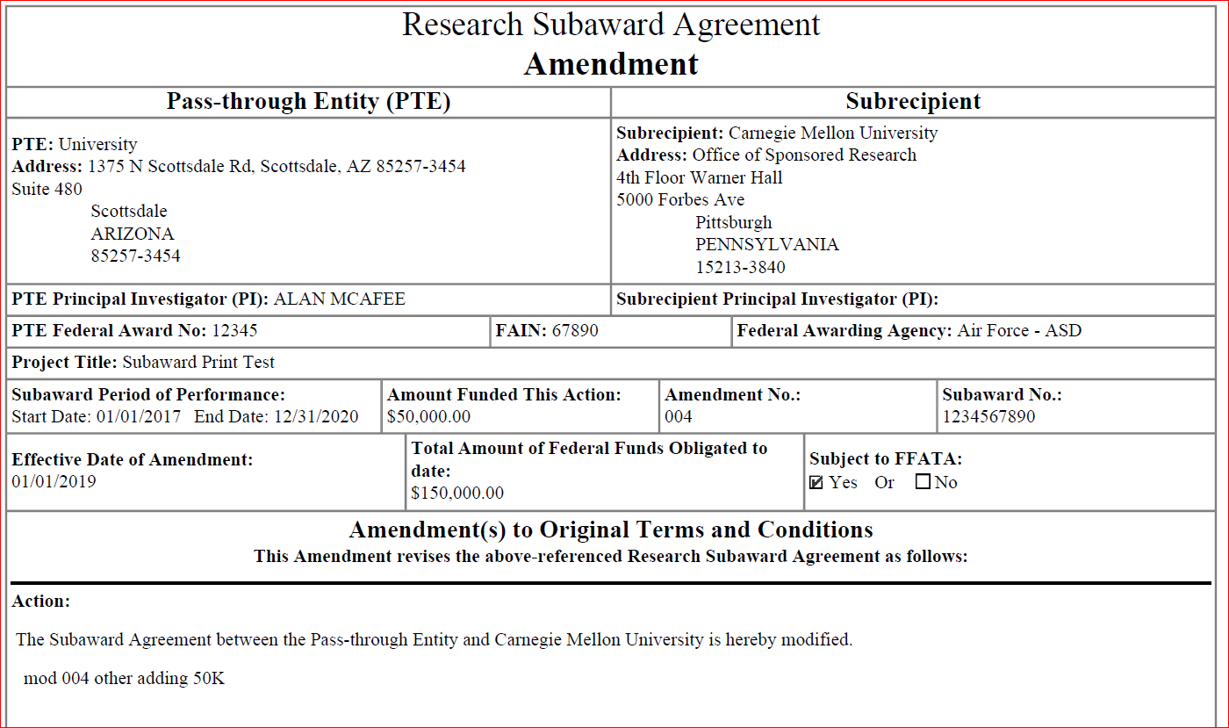



Screenshot from Kuali Demo FDP Modification printout #2 for ‘Other’ after Subaward is edited and submitted without changes creating Subaward version #8 is provided below.

